JFS-PROJECT SCREEN SHOTS
REG-NO: 42110216

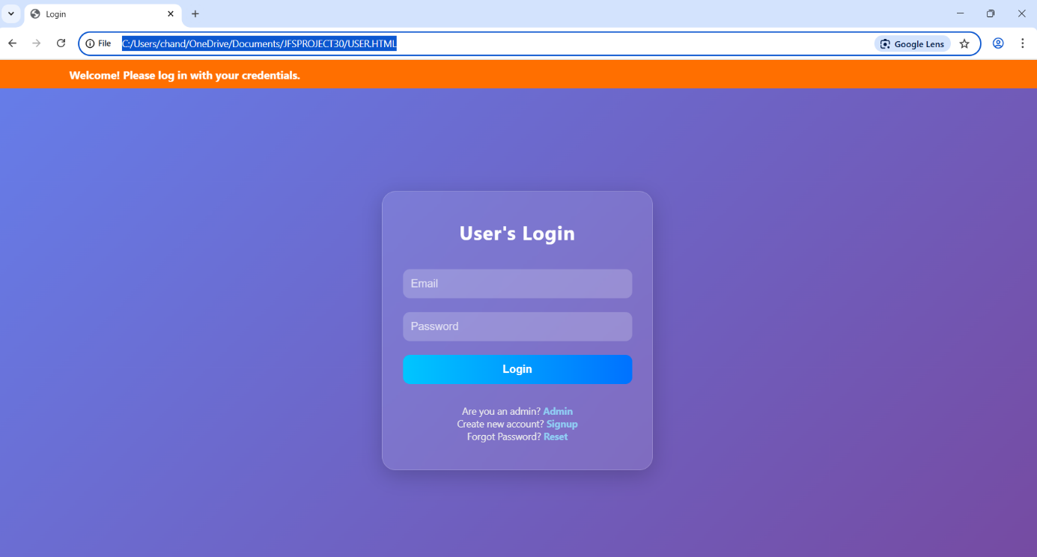
1.1 USER LOGIN

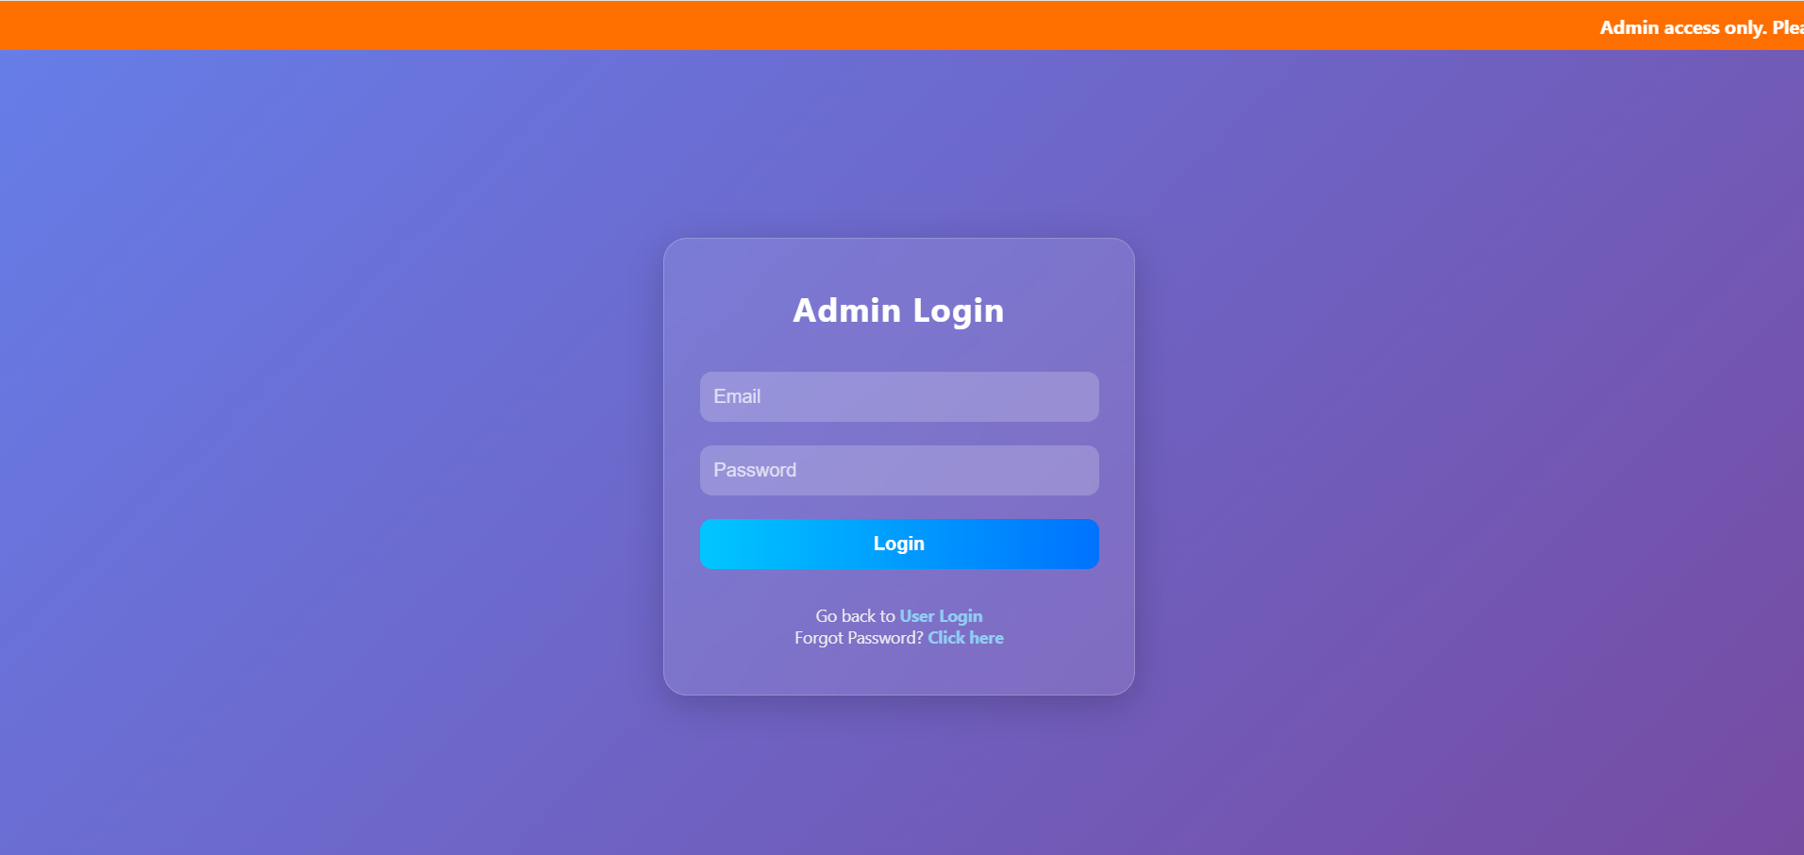
1.2 ADMIN LOGIN
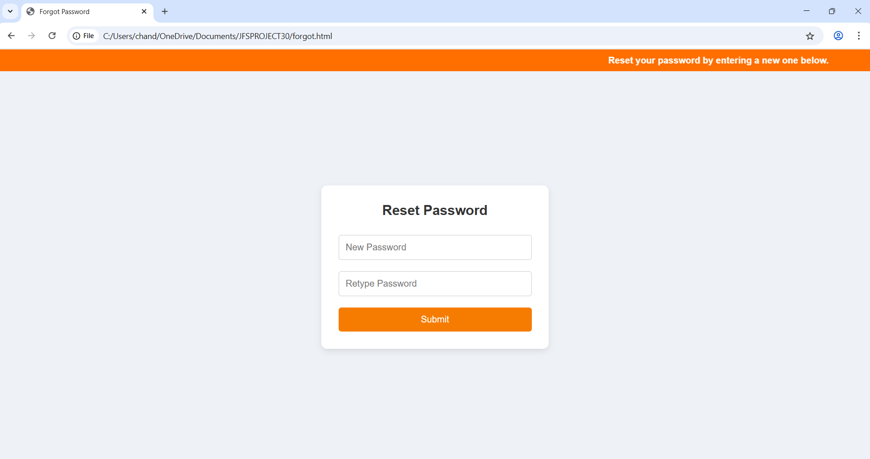

1.3 FORGOT PASSWORD PAGE

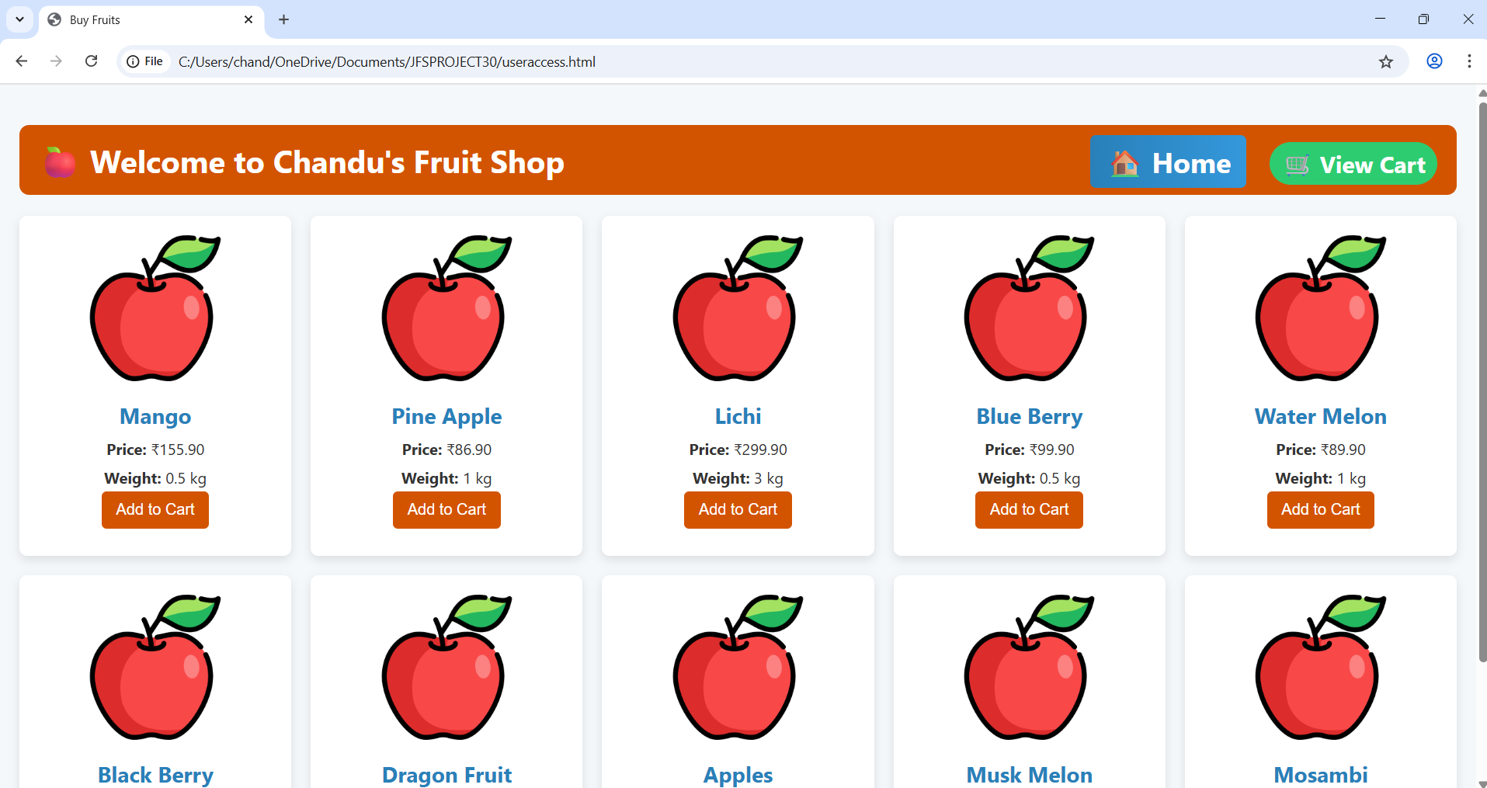

1.4 USER HOMEPAGE
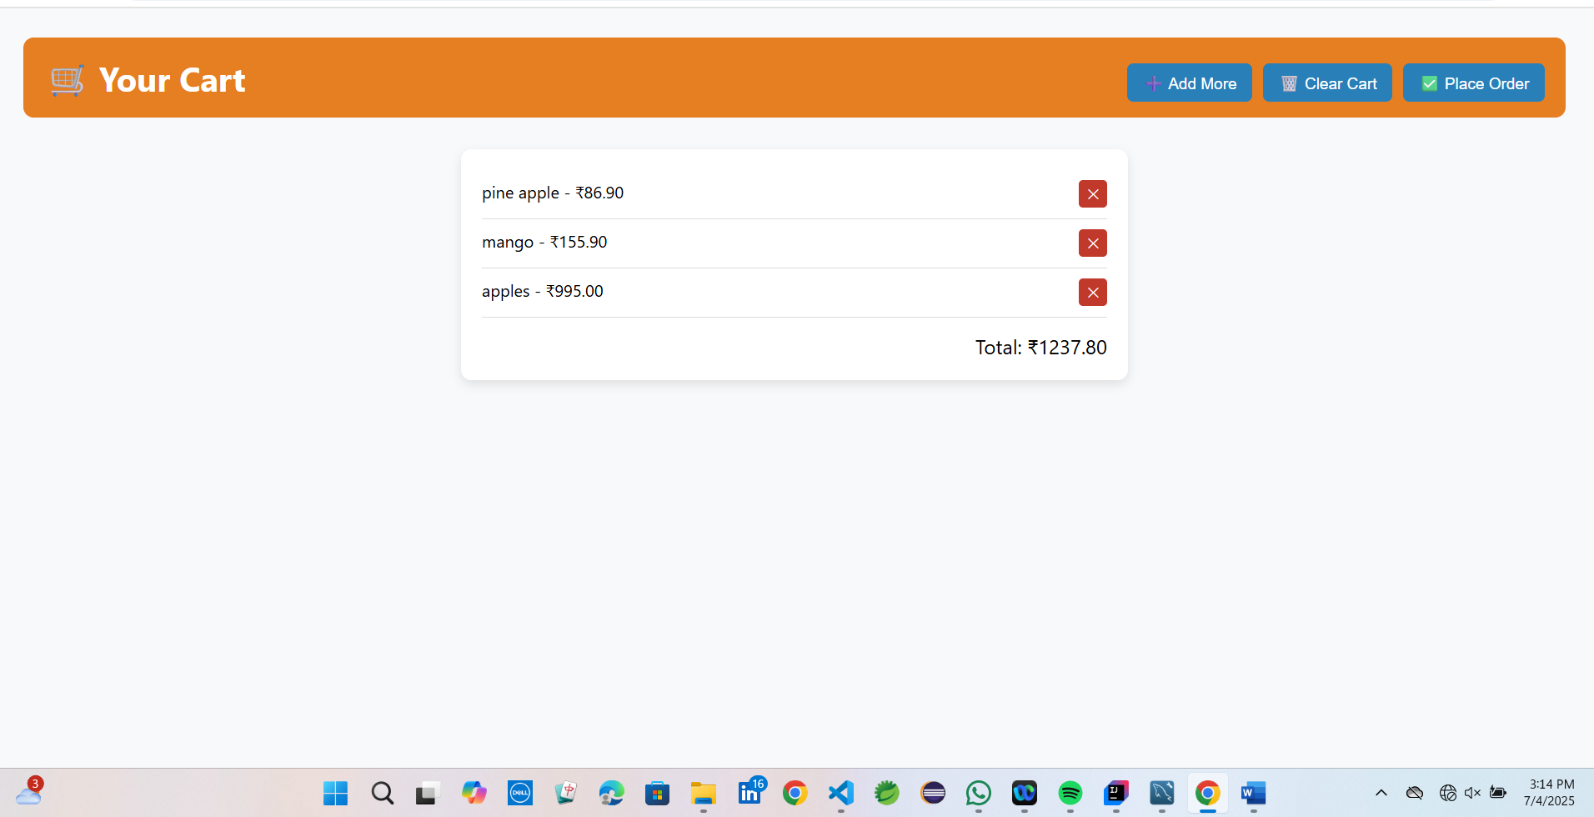

1.5 USER CART PAGE

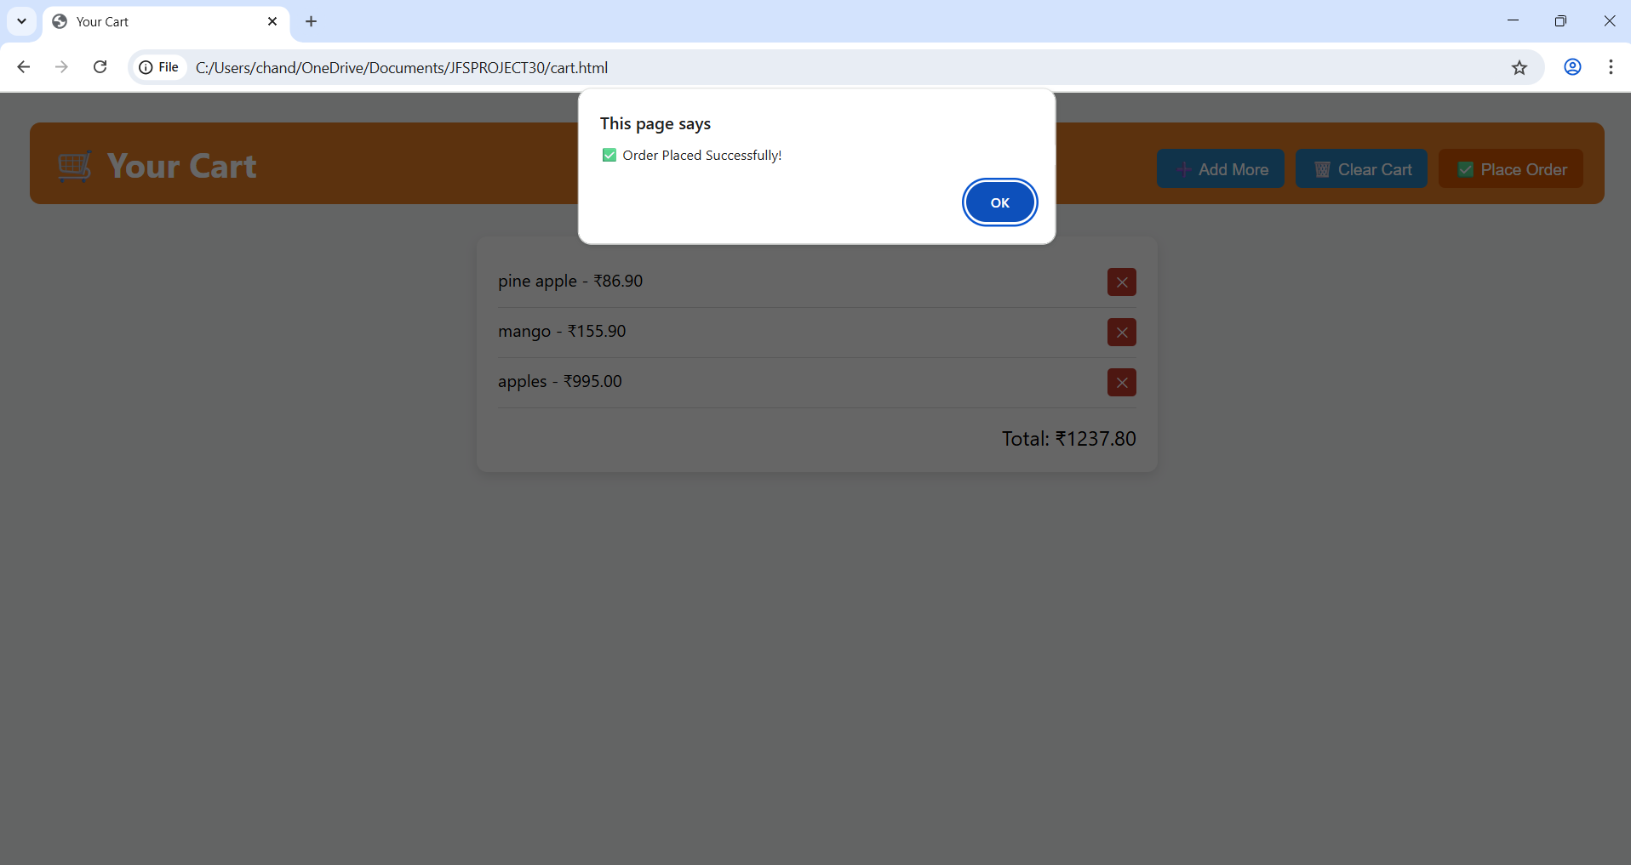
1.6 ORDER STATUS

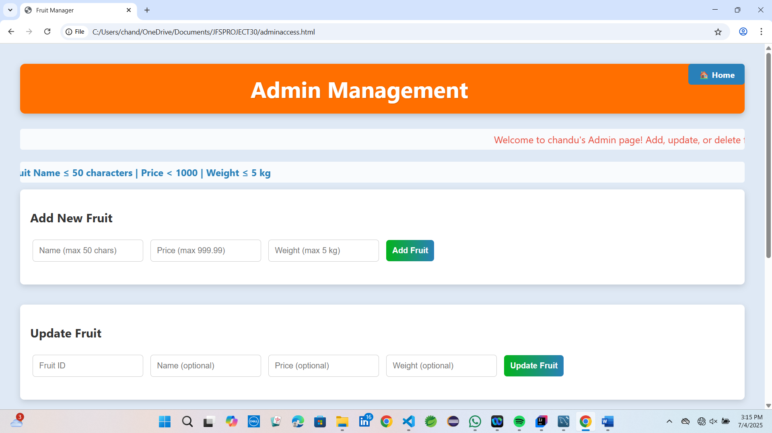
1.7 ADMIN HOME PAGE

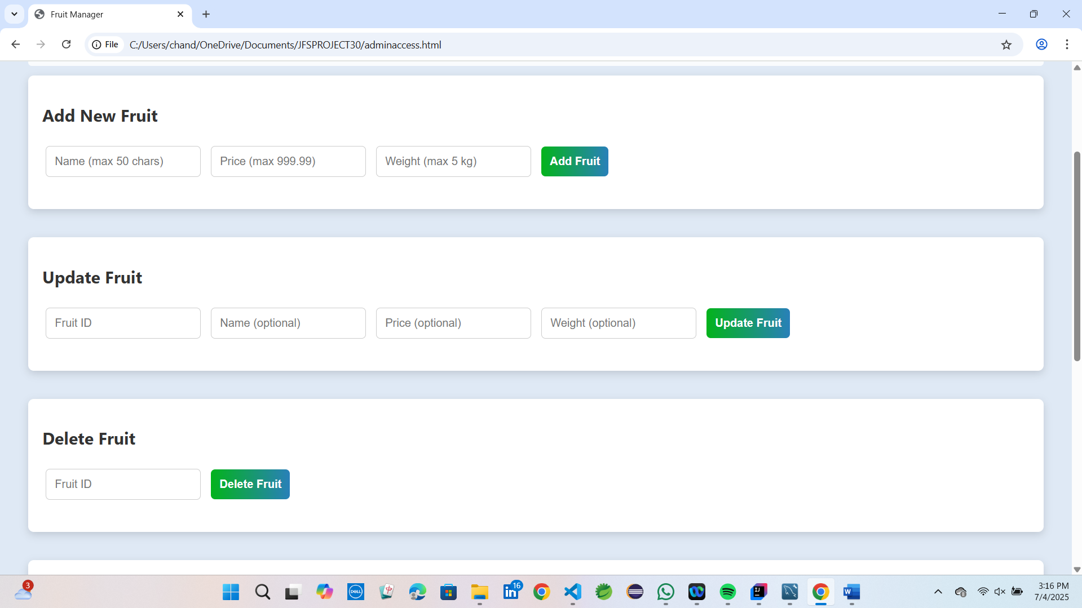

1.8 ADMIN OPERATIONS
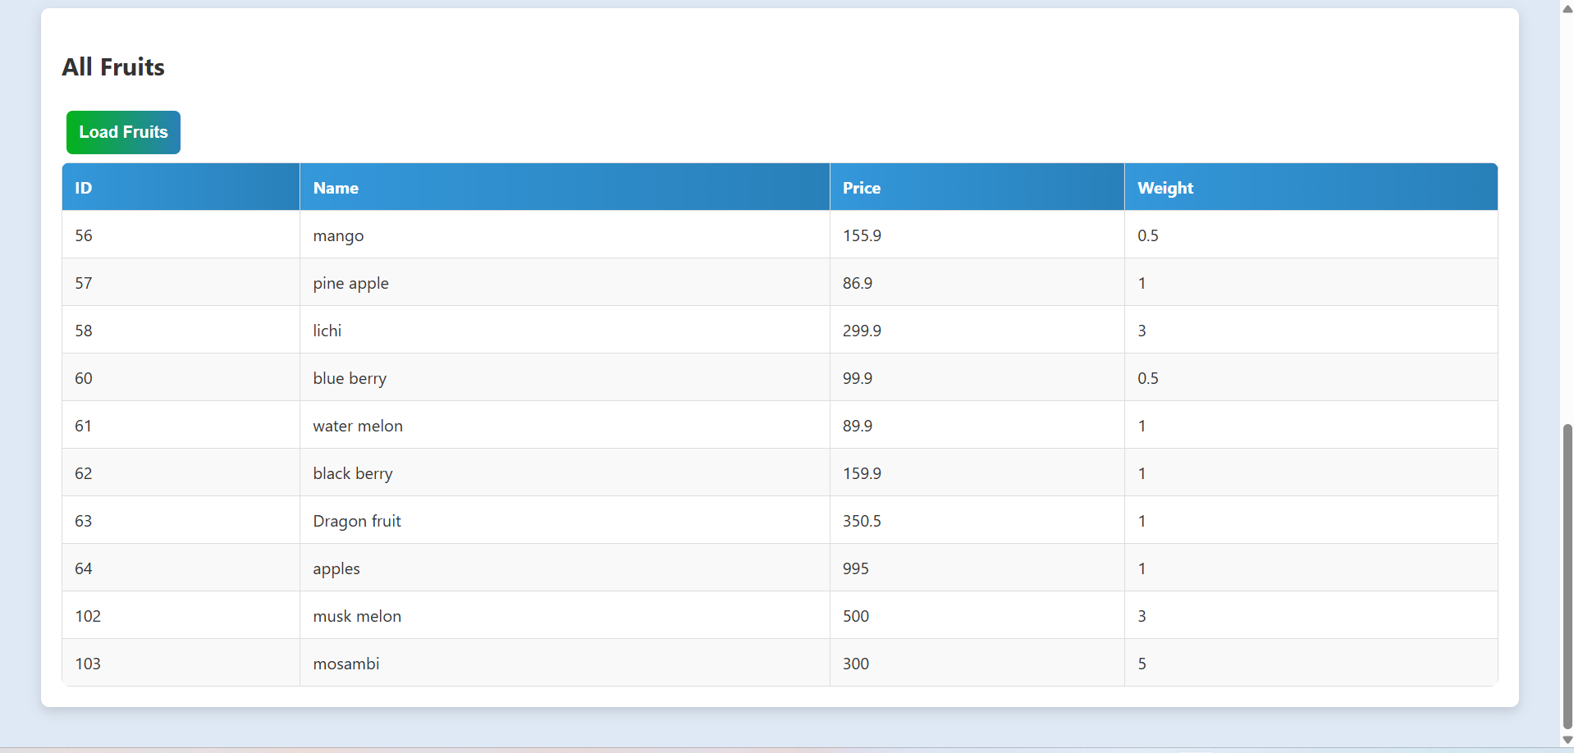
1.9 ITEMS ACCESSED BY ADMIN

